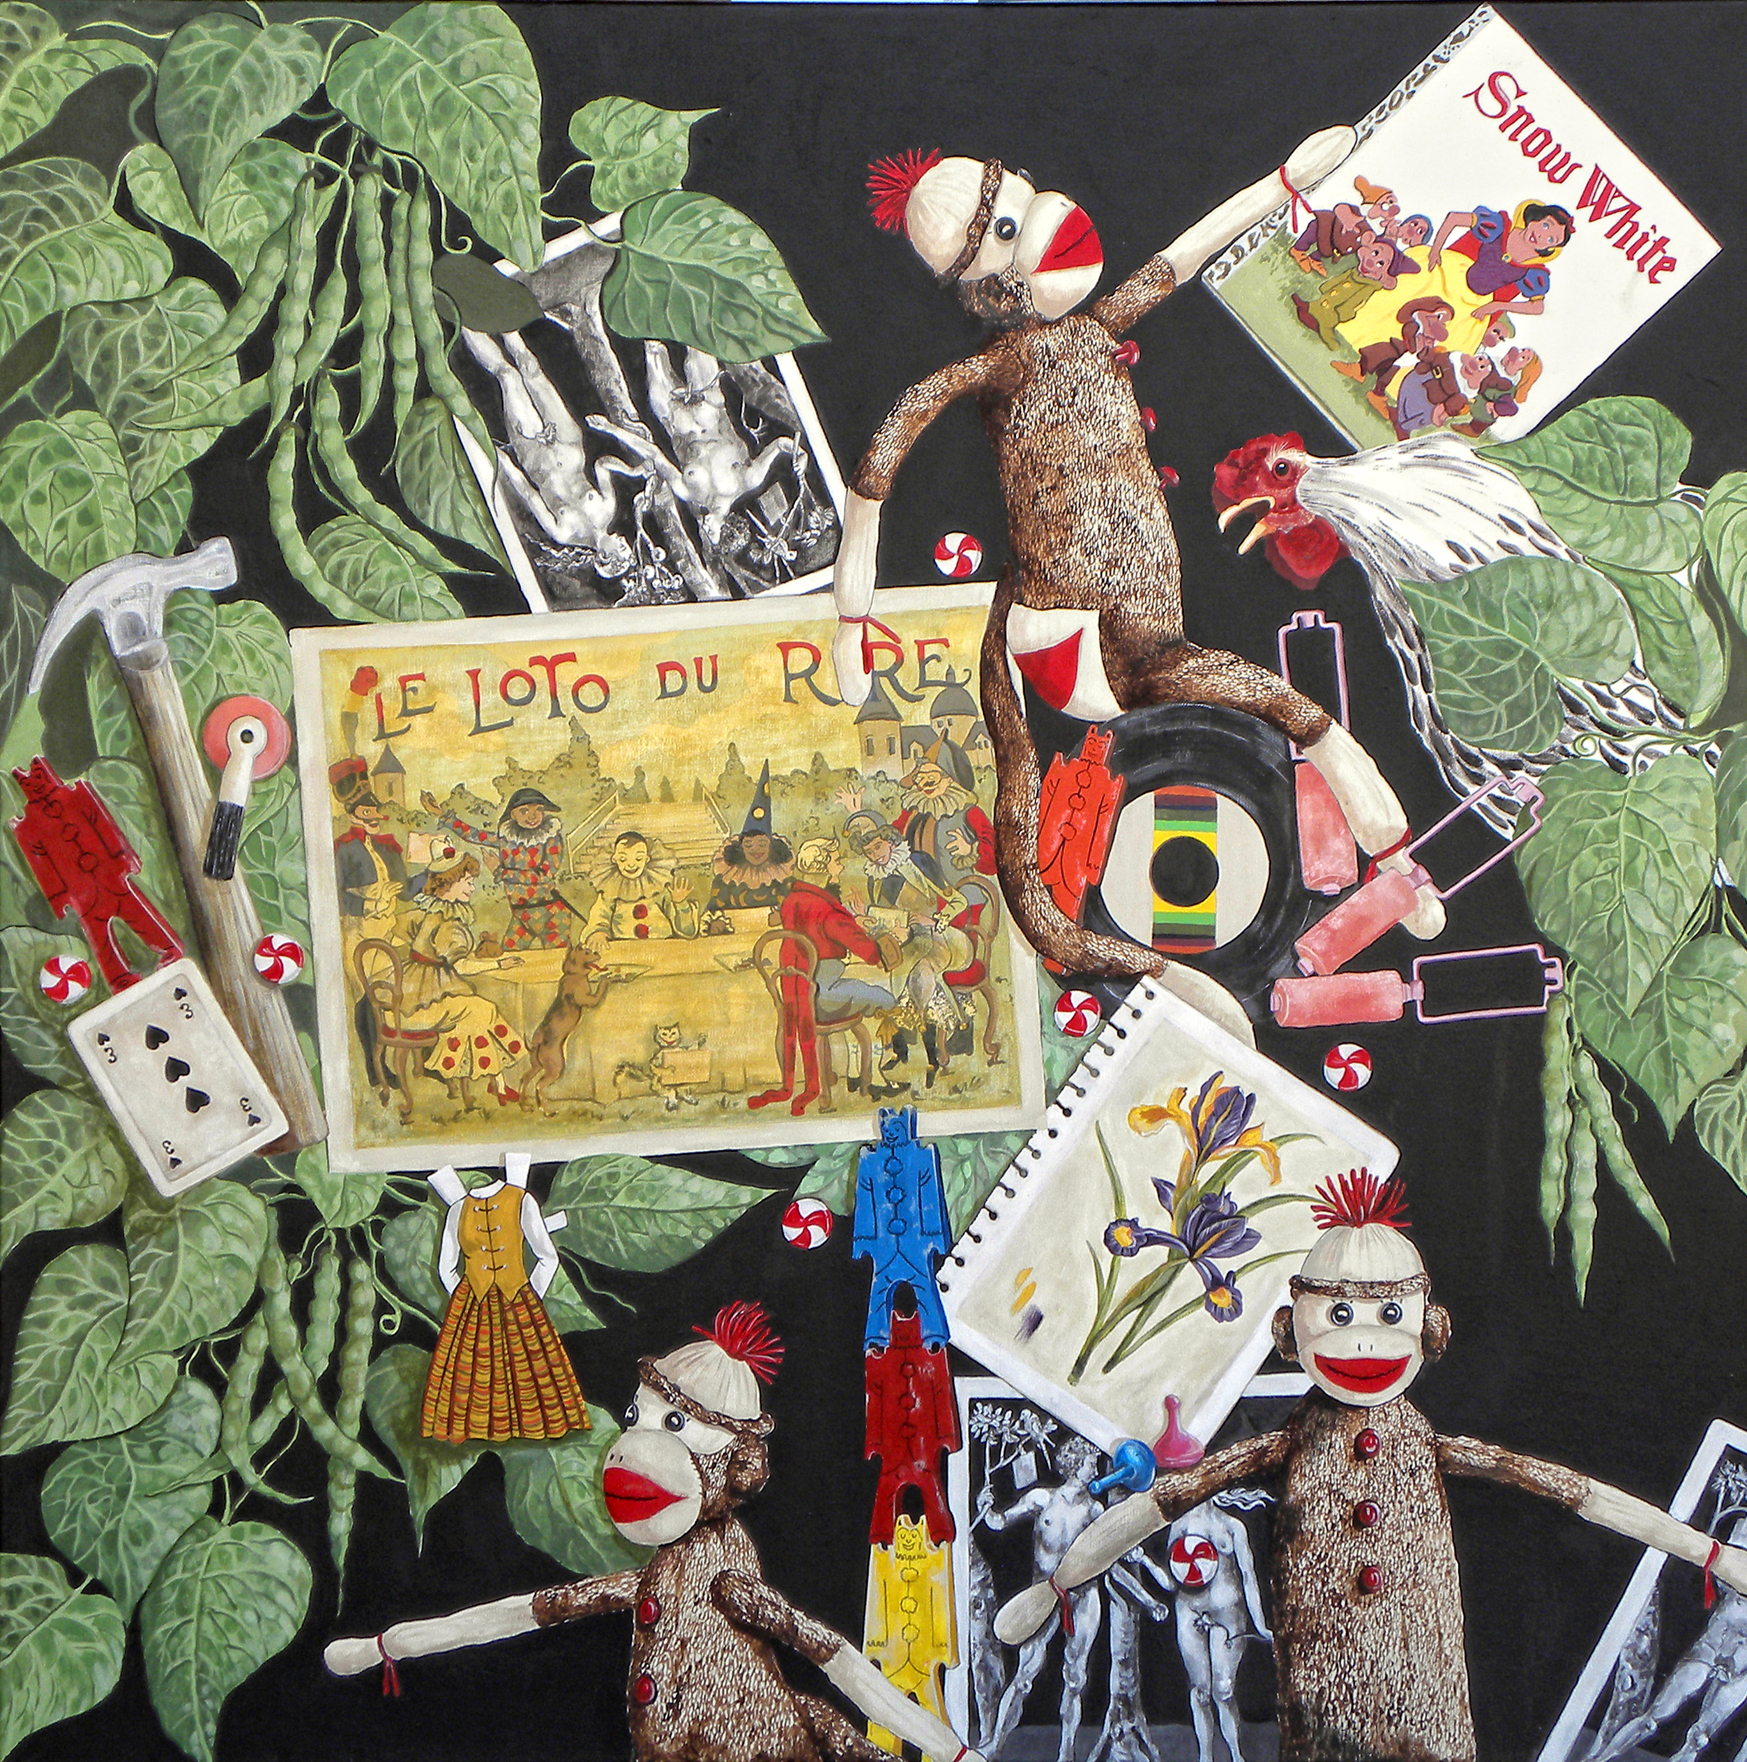

Nicolette Maguire Bonnstetter
nic@nicsart.com email Nicsart.com web site
402-417-5614 cell

EDUCATIONAL PREPARATION

1990 M.A University of Nebraska-Lincoln, Lincoln, Nebraska
Major: Art Education
Thesis: Examining Textbook Bias/ Implications for Art Education
Focus: women in art

1973 B.S. Mankato State University, Mankato, Minnesota
Major: Art (K-12 Teaching Endorsement)
Areas of Concentration: Textiles, Drawing, Printmaking, and Pottery

PROFESSIONAL EXPERIENCE

Location Dates Duties

Jury for creation art exhibit Feb 2020 selected art for 1,000 prize

Jury prep and artist critiques 2013 to present review art

University of Nebraska-Lincoln 1994-2008 Instructor:
Lincoln, Nebraska C&I 403 Seminar

University of Nebraska-Lincoln 1989-2008 Student Teaching
Lincoln, NE Supervisor

University of Nebraska-Lincoln 2000-2008 Large-group coordinator
Lincoln, NE

Nebraska Wesleyan University 2002 Instructor: Art Methods
Lincoln, Nebraska

Southeast Community College 1994-2004 Instructor: Art Appreciation
Lincoln, Nebraska

Southeast Community College 1997-2000 Instructor: Women in Art
Lincoln, Nebraska

Nebraska Wesleyan University 1999-2000 Instructor: Art Methods
Lincoln, Nebraska Studio, inclusive, drawing
Printmaking, painting
Nebraska Wesleyan University fall 2000 Instructor: Modern Art
Lincoln. Nebraska

University of Nebraska-Lincoln 1987-1993,1998,2000 Instructor: Elementary Lincoln, Nebraska Art Methods, Studio,
Inclusive Drawing,
Painting, and Printmaking

University of Nebraska-Lincoln 1995-1998 Instructor:
Lincoln, Nebraska C&I 297 Practicum

State of Nebraska 1991-1993 Prairie Vision:
Department of Education (art) Consultant

State of Nebraska 1990-1991 Implementation Department of Education Coordinator:
Getty Art Center for
Learning Grant
Exhibits

Baltimore American Crafts exhibit (juried). April 2021

Manhattan juried Arts, Exhibit, Her Story Dec. 2020- March 2021

Camelback Gallery, Phoenix, AZ, Shades of Red international exhibit finalist 2020

Magic and Dreams juried Sedona Center for the Arts May-June 2020

Celebration of 2020 Artists, juried, Peoria Art Gallery March 2020-May 2020

Showcase exhibit (juried) Desert Foothills Gallery, Cave Creek, AZ, October –Jan. 2020

The Heat is ON! Arizona Art Alliance, Phoenix, AZ July –August 2019

Make me Laugh! Holland Gallery of Fine Art, Scottsdale, AZ juried group, April 2019

Feathers and Flowers 7 Arizona Artists, Herberger Art Gallery, Phoenix, AZ Feb. 2019

Holiday Highlights, Memories, juried, Shemer Art Gallery, Phoenix, AZ Nov. 2018

Retrospective 180 Gallery, Phoenix ,AZ Oct-Jan.2018

Beloved Beasts, juried, Shemer, Phoenix, AZ August 28- October 4 2018

Hot Art! –Cool Show juried Desert Foothills Gallery, Cave Creek, AZ July-Oct. 2018

Herberger invitational Un Wind, March-May 2018

Terravita (duo exhibit )Art Gallery exhibit Jan-March 2018

Memories exhibit, developer, Desert Foothills Art Gallery, Sept. 2017 Cave Creek AZ

First Studio, July-September 2017, Phoenix, AZ

Art Object Art Gallery, invitational, April-March 2017, Carefree, AZ

Contemporary juried Exhibit, The Desert Foothills Gallery, Feb.-March 2017, Cave Creek, AZ

Interpretations II, second annual juried exhibit, WHAM, West Valley Gallery, March 2017, Phoenix, AZ

Hidden in the Hills Studio Tours 2017 Scottsdale, AZ

Adornments one person exhibit March 2016 Scottsdale, AZ

Contemporary juried Exhibit Desert Foothills Gallery, Jan.-March 2016, Cave Creek, AZ

COLOR! Holland Gallery of Fine Art, two person exhibit, Dec.2015-Jan. 2016, Scottsdale, AZ

Hidden in the Hills Studio Tours Nov. 2015 Scottsdale, AZ

Terrestrial Wood, juried exhibit, Shemer Art Center, Sept. 15-October 15, 2015, Phoenix, AZ

Hidden in the Hills juried Featured artists Desert Foothills Gallery Oct-Dec. 2015 Cave Creek, AZ

Selected for the Southwest Invitational Exhibition featuring 100 Arizona Artists. March 2015 –May 30th. Yuma Art Center, Yuma, AZ

Juried Contemporary Art Invitational , Desert Foot Hills Library Art Space, Cave Creek AZ Jan 30-March 27, 2015

Art in Public Places Juried exhibition National Bank of Arizona Dec 2014 –February 2015

Hidden in the Hills Studio Tours Nov. 2014 Scottsdale, AZ

Selected for Desert Foothills Gallery preview exhibit, Hidden in the Hills, Cave Creek, AZ Oct-Nov. 2014

Lets Talk Art, Holland Gallery of Fine Art, Scottsdale, AZ October 2014

One Woman Exhibit, Sonoran Art League, Cave Creek, AZ Aug. Sept. Oct 2014

Art in Public Places Juried exhibition National Bank of Arizona March –May 2014

Contemporary Art Show Dessert Foot Hills Library Art Space Dec 13-April 4, 2013
Cave Creek, AZ 200 applicants 23 juried in

Selected for Peace Garden Exhibition Scottsdale AZ Nov. 2, 2013

Archival-a Retrospective, Weyland Gallery, Epworth, IA, February-March 2010.

Nebraska Artists…Great Plains Center for the Arts, Lincoln, NE, 30 Nov 2009.

Nebraska IMPACT best, Octagon Center for the Arts, Ames Iowa, Featuring Nebraska Artists, June 5-Aug 2 2009.

Kooser IMPACT, Neihardt Gallery, Bancroft, NE April 2008.

Nebraska Games of Life, Carnegie Art Center, Alliance, NE, March 1-April1 2008.

Group show, Fremont Gallery, Fremont, NE March –April 2008.

Kooser IMPACT, Creighton Leid Center for the Arts, Omaha, NE, Aug-Sept 2007.

Nebraska IMPACT BEST, Columbus Art Gallery, Columbus May-June 2007.

Nebraska Kooser IMPACT, Norfolk Art Gallery, Norfolk, NE March-April 2007.

Saatchi Gallery United Kingdom, London online selected juried competition SHOW DOWN, March 2007.

Group Show, Albright Kemper Museum. St Joe, MO, Nov-Jan 2006.

Games of Life, Coutts Museum, Eldorado, KS, May 2006.

New Perspectives, Christlieb Collection, Lincoln, NE, Jan 6-March 26 2006 juried invitational.

Nebraska IMPACT Plainsman Art Museum Group show, Auroa, NE, Nov. 1-Dec. 1 2005.

Jewish Center for Arts, Omaha, NE, Feb. 2-28th 2005 juried invitational.

Haydon Art Center, Lincoln, NE, Nov. 5-Dec. 29th 2004 juried invitational.

A celebration of Visual Artists, Dawson Museum, Lexington, NE, Sept 1-Oct. 30, 2004
A Celebration of Visual Artists , Museum of Nebraska Art, Kearney NE, July 6-Aug 29, 2004 juried invitational.
Bemis Center for Contemporary Arts, Omaha, NE, Window Competition, May 2003.

Impressions, Blanden Memorial Art Museum, Fort Dodge, IA, Jan. 17- March 23, 2003, juried regional.

One Woman Exhibit, South East Community College, Lincoln, NE, June-Sept. 2002.

National traveling show, Cards, July 2002-2004, Women’s Impact…Scotts Bluff Art Gallery, NE.

Robert Hilestad Textile Gallery, Lincoln, NE. “Storefront Dressing”, May 1- May 31, 2002.

National show, Mothers and Daughter’s, Midwest Women’s Cacaus Regional Invitational, Art West Art Center, January 2002-2003.

Hot House, Kansas City, Missouri…Jan.1-March 31, 2002.

South Bend Art Gallery, South Bend, Indiana…May-July 2002.

Hilmer Art Gallery…Omaha, Nebraska…Sept 20-Nov.1, 2002.

Colfax Gallery, St Louis, Missouri… Nov. 10-Dec. 8 2002.

Beacon Street Gallery, Chicago, Illinois…Jan. 10-Feb. 22, 2003.

Piece of My Mind, Norfolk Arts Center, Norfolk, NE, Jan. 17 - Feb. 28, 2002.

Fifth Journey…Kansas City Library, Kansas City, KS., Nov. 19 - Jan 9th, 2001-2002.

Group invitational…Dawson County Historical Society, Lexington, NE., Nov. 2-Nov.30, 2001.

Life Cycles Nebraska Women’s Caucus for Art, Burkholder Art Gallery, Lincoln, NE, Oct 2001.

Life Cycles Nebraska Women’s Caucus for Art, Creighton University Art Gallery, Omaha, NE. Aug 18-Sept 8. 2001.

Center for the Arts, Omaha, NE, July 2001.

Visual Art, Elder Gallery, Nebraska Wesleyan University Faculty Show, Lincoln, NE Nov. 1-Dec. 15, 2000.

One Woman Show Emerging Patterns, University Art Place, Oct. 1999, Lincoln, NE.

Paper Doll II, Self Portrait Art & Narratives, Rall Gallery, Doane College, Crete. NE, March, 1999.

Paper Dolls: Self Portrait Art & Narratives, Creighton University Exhibition, August, 1998, Omaha, NE.

Featured Artist, Standard Blue - Lincoln, NE, July 27 - August 1, 1989.

Beaux Arts Festival, Davenport, Iowa, Putnam Museum of Art, 1983, 1984, 1985, 1986, 1987 juried invitational.

Boulder Arts, Boulder, CO. 1986, 1987, 1988 juried invitational.

Selected Iowa Artist, Des Moines, IA Cultural Center for the Arts, August, 1981 and 1985,
University Iowa, Iowa City, IA 1982, 1983, 1984, 1985 juried invitational.

Winter Arts Festival, juried invitational, Estherville, Ia. 1977, 1979.

Rochester Art Festival, juried invitational, Rochester, Minnesota, 1974.

Commissions

1990 Lincoln, Nebraska Children's Museum, Lincoln, Nebraska, mural

1987 University of Nebraska, Lincoln, Nebraska, mural

1985 South Gate United Methodist Church, Lincoln, Nebraska , Mural

1978 Northern Natural Gas, Rockwell City, Iowa , mural

1974 Elks Musical Extravaganza , Muscatine, Iowa, set design

Professional Distinctions

Selected artist for featured program Holland Center of Fine Art, Scottsdale
Oct. 2020

Studio tour selection, Phoenix Art tours Feb 12 , 2020

Selected to jury Art Faith Collective Phoenix, AZ March 2, 2020

Relentless Talk Radio interview June 1 2020

Featured artist Guild Art Magazine Oct-Nov. 2017 AZ

Juried member of Arizona Art Alliance 2017

Selected Juried member Sonoran Art League 2015

Member of American Women Artists 2014

Judge for the Sonoran Arts League Visual Arts Scholarship February 2014

Selected Juror for The Senora Art League (900 members) monthly critique 2013 to present, Cave Creek, AZ

Student art work selected for use at the 2007 Olympic games St Monica’s Adolescent Girls program.

Selected 2006, Honored Care Award recipient presented by St Monica’s, Lincoln, NE.
Honored by Ruth Hill Elementary School, Lincoln, NE for work in art,
30th anniversary school celebration, 2006.

National Art judge for Reading Rainbow Young writer and illustrator contest, April 2003.

Juried into Impact, select regional art organization, 2002.

Organizer of Women in the Arts, community outreach program, Lincoln South East High, 1998,Lincoln, NE.

Teaching Award, nominated by parents and students of the University of Nebraska-Lincoln - 1991-1993 (award began in 1989).

Board Member, Education Committee, University Place Art Center/Wesleyan - 1991-1992.

Nominated Getty Art Task Force (United States) -Bringing Art to the Classroom1990.

Art Judge, CBS Television Storybreak Young Reader – 1989.

Haymarket Art Board - 1984-1986, Lincoln, NE.

Chairperson, Estherville Winter Arts Festival, Estherville, Iowa - 1977-1980.

Organizer and President of Lakeland Area Art Association - 1978-79

Organizer and Judge, Special Arts Olympics for North Central Iowa, Lakeland AEA - 1978-1979.
Professional Activities
Holland Gallery Scottsdale AZ
Presenter Jury Prep presentation Sonoran Art League Feb 2021

Critique reviewer for jury presentation Sonoran Art League March 2020

Sonoran Art League featured artist Ukrainian Patterns Nov. 2018

Art, Conversation, and Coffee monthly critique and discussion at Holland Gallery of Fine Art Exhibits. 60th and Carefree Hwy, Scottsdale, AZ 2017 on going

Presenter Art Leagues of AZ Jan 2018, AZ Art Alliance, How to Look at Art, Phx, AZ

Art, coffee, and Conversation, Holland Gallery of Fine art, moderator monthly

Terravita Art League presentation “Looking at Art” Oct. 2017

Arizona Artist Guild, Phoenix, 2017

Coordinator Sonoran Art League Critique Venue, monthly for members and nonmembers 2017 on going

Sonoran Art League mock juror and critique workshop February, Scottsdale, AZ, 2017

Women of the Pen presentation February, Phoenix, AZ, 2017

Sonoran Art League education committee, art workshops 2014, 2015, 2016

Brandeis University Studio chosen for site visit, February 24, 2015.

Facilitator/ developer Holland Gallery of Fine Art, Scottsdale, AZ, July 2014-2017

Amazing Women! Art Nosh Talk, in conjunction with the Phoenix Art Museum, Cave Creek, AZ Sept 3 /14

Women in the Arts, 5 week seminar, Senoran Art League, Cave Creek, AZ, Sept-Oct

Member of the Art Talk, working artist group , Carefree, AZ 2012-present

Member of the Senora Art League Carefee/Cavecreek AZ 21012-present

Presenter Hildegard von Bigen as Woman of Power, Great Plains Center for the Arts, August 2011.

Committee for artist Hildegard Tour Committee, 2010-11.

Selected OLLI artist studio tour, April 2009.

Lets Talk Art, panel discussion with Norman Geske, Robert Ripley, Nicolette Bonnstetter, What is the Museum’s Obligation to Contemporary Art? Sheldon Museum of Art, March 16, 2008.

Haydon Art Center Open Studio Tour, featured artist, Sept 8,9th 2007.

Presenter OSHER Life Long Learning Institute, Lincoln NE April 2007 Women Artists and Feminism.

President of IMPACT a select Nationally recognized group of artists that represent Nebraska in and outside the state, 2005-2008.

Chair of Sheldon Memorial Art Gallery Family Artist Day, April 3, 2005 (400 participants).

Lincoln Art Council grant reviewer 2005.

Haydon Art Center Advisory member, 2004-2005.

Nebraska Women’s Art Caucus board member, 2004 2005.

Arts are Basic Board, Program to infuse art into the school setting, 2002-to 2004.

Sheldon Memorial Art Museum Education board, 2003- 2006.

Making the National Connection: History, Purpose and Ideal of the National Caucus for Art, Roundtable panel, Lincoln, NE, Feb. 16, 2002.

Nebraska Art Association Sheldon Education Committee, 2002-2005.

Gallery Representation, University Art Place, 1998 -2002, Lincoln NE.

Art consultant for “Illuminations” publication of the arts (South East Community College ) 1998-1999.

Nebraska Women’s Art Caucus 1996 –2010.

Nebraska Art Association member 1994 –2010.

Presenter ESU Women in the Art curriculum 1994...Syracruse, NE.

Vice President University of Nebraska Faculty Women, 1994-1995.

Presentations, art, and curriculum, organized through the state department of Nebraska, Nebraska City, Auburn, Burwell, Bennet, Syracuse, Sterling, Benedict, Schuyler, Central City, Kearney, Nebraska, 1991-93.

University Place Art Center Speaker, Hidden Women Artists – 1993.

Presentation ESU #4 Workshop, Class I Teacher Inservice, Art in the School, August, 1992, Lincoln, NE.

Presentation ESU Workshops Art integration, 1992 , Auburn, NE.

Anchorage Schools Presenter The Art of Science/Integrating art and science, 1991.

University Place Art Center Speaker, "Looking at Mona, new developments in Art Education” 1991.

Art Judge, Joslyn Art Museum, Omaha, Nebraska for Student Exhibition – 1991.

Organizer and Chair, Ruth Hill Elementary Art Night, Lincoln, NE, 1987-1988-1989.

Speaker Nebraska Wesleyan University, Our Journey Workshop – 1988.

Graphics Designer, Jan Lynn Corporation - 1980-1984.

Graphics Designer, Better Homes & Gardens - 1980-1984.

Commercial Artist, Universal Stickers Inc. - 1983
Reviews

Featured artist in AZ Images magazine, Art Work with Wit, Wisdom. and Wonder by Donna Kublin June 2014

Hidden in the Hills Artist Studio Tour “The“Stuff” of Life” Participant artist review
On line Julia@wrote designaz.com June 4, 2014

The Foothills Focus: New Color, Space Dimensions Delight Artist, by Shea Stanfield
January 15, 2014

Featured artist in Desert Foothills Chronicle, Carefree AZ Sept. 2013 Nicolette Bonnstetter Color and Space Lead to a New Dimension

Feature article Lincoln Journal Star Sept 2009 Real Nebraska, through the eyes of Nebraska Artists.

Dr. Altman, Starcrossed, Color and 3-D Utube interview with Nicolette Bonnstetter, 2008.

Ground Swell, Columbia Missouri, winter 2008, Midwest Art and Culture, IMPACT.
Quarterly Art Magazine, writer Doug Meigs.

Nofolk Daily News, March 14thm 2007, Artists illustrate Pulitzer Winning Poet’s Words, writer Sheryl Schmeckeper.

Omaha World Herald, March 17, 2007, Nebraska Artists Visualize Poet’s Words,
Norfolk Daily News, March 3m 2007, Impact on Nebraska, writer Sheryl Schmeckerpeper.

Daily Nebraskan, Jan 17th, 2006…Women Progressing in Art World ,Nicolette Maguire Bonnstetter featured writer Astrid Munn.

The Ink People News, vol. 27, #10 October 2006, Nebraska Artists.

Lincoln Journal Star, August 21, 2005…Art Around Town, writer Kent Wolgamott review of IMPACT artists.

Lincoln Journal Star August 28, 2005, Funky Shui, art in the home, feature/ Nicolette Maguire Bonnstetter, Linda Ulrich writer.

L magazine , Lincoln , NE, December 2005 …Art IMPACT, story Barbara Rixstine, photos Pam Thompson.

L Magazine, Lincoln , NE, December 2004, A Visual Journal, Nicolette Bonnstetter, stories and photos by Anne Pagel writer.

Kearney Hub, Kearney NE, August 12, 2004…Inspired Artists, Nicolette Maguire Bonnstetter featured, writer Jan Thompson.

Norfolk Arts, Norfolk , NE, vol 18, issue 3, Sept 2003, IMPACT Artists Games of Life.

State Paper.com, Anne Pagel, August 21, 2001...Women’s Caucus Life Cycles review, Nicolette Maguire Bonnstetter featured.

